Blue Team: Summary of Operations

Table of Contents
- Network Topology
- Description of Targets
- Monitoring the Targets
- Patterns of Traffic and Behavior
- Suggestions for Going Further

Network Topology
The following machines were identified on the network:

Target 1
- Operating System: Debian GNU/Linux 8.11 (jessie)
- Purpose: Victim Machine 1
- IP Address: 192.168.1.110

Target 2
- Operating System: Debian GNU/Linux 8.11 (jessie)
- Purpose: Victim Machine 2
- IP Address: 192.168.1.115

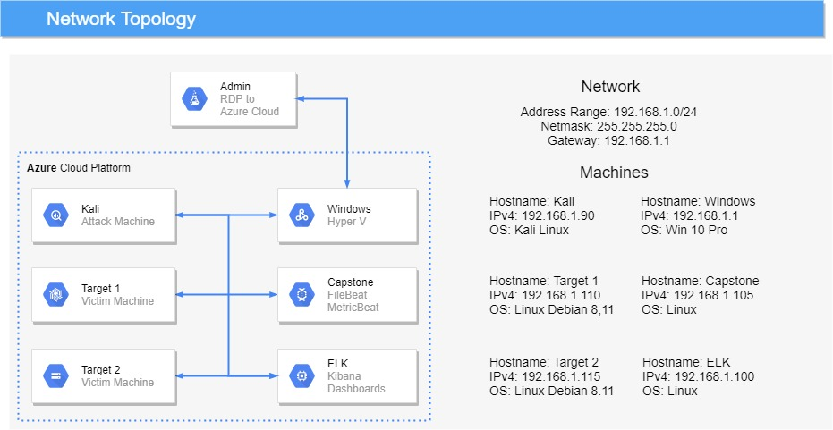

Description of Targets
Fill in the following:

- Two VMs on the network were vulnerable to attack: Target 1 192.168.1.110 and Target 2 192.168.1.115

- Each VM functions as an Apache web server and has SSH enabled, so ports 80 and 22 are possible ports of entry for attackers.

Monitoring the Targets
This scan identifies the services below as potential points of entry:

- Target 1
  - Apache webserver running on Port 80
  - SSH running on port 22
  - SMB running on ports 139, 445
  - Rpcbind running on ports 111, 53927

- Target 2
  - Apache webserver running on Port 80
  - SSH running on port 22
  - SMB running on ports 139, 445
  - Rpcbind running on ports 111, 51544

Traffic to these services should be carefully monitored. To this end, we have implemented the alerts below:

Excessive HTTP Errors

Excessive HTTP Errors is implemented as follows:

- Metric: http.response.status_code
- Threshold: above 400 for the last 5 minutes
- Vulnerability Mitigated: Alerts to scans on the website such as wpscan, dirb, nikto, go buster
- Reliability: This alert has a high reliability as normal use of a website does not produce a large amount of HTTP errors in a short period of time.
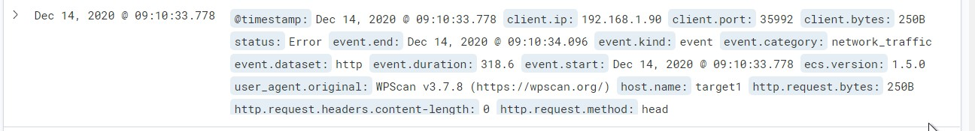

HTTP Request Size Monitor

HTTP Request Size Monitor is implemented as follows:

- Metric: http.request.bytes
- Threshold: Above 3500 for the last 1 minute
- Vulnerability Mitigated: Prevent users uploading large files, such as the exploit.sh and potential DoS attacks
- Reliability: This alert has a high reliability as normal use of the website should not trigger this alert. Could be set to a lower amount as the only thing users upload to the website is the comments on the contact page.

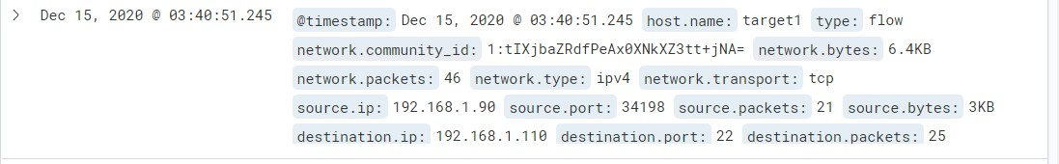

CPU Usage Monitor

CPU Usage Monitor is implemented as follows:

- Metric: system.process.cpu.total.pct
- Threshold: Above 0.5 for last minutes
- Vulnerability Mitigated: Availability of website
- Reliability: This alert has a high reliability as normal use on the webserver should not trigger this alert unless a large amount of traffic happened at the same time such as an advertising campaign was running.

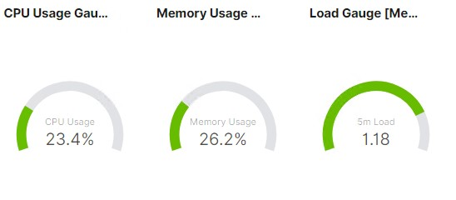
OTHER alerts to consider

Monitor all SSH logins – successful and unsuccessful
Monitor sudo commands by user – and sudo errors by user

Suggestions for Going Further

Suggest a patch for each vulnerability identified by the alerts above. Remember: alerts only detect malicious behavior. They do not prevent it. It is not necessary to explain how to implement each patch.

The logs and alerts generated during the assessment suggest that this network is susceptible to several active threats. In addition to watching for occurrences of such threats, the network should be hardened against them. The Blue Team suggests that IT implement the fixes below to protect the network:

Vulnerability 1
- Patch: Harden Wordpress website and mysql database
- Why It Works: Reduces the attack surface of WordPress and mysql database as default settings make it easier for attackers to locate information to assist with attacks.

Vulnerability 2
- Patch: Installing fail2ban or faillog to lock accounts that have too many failed login attempts
- Why It Works: Reduces brute force attacks as accounts are locked when too many failed login attempts occur in a short period of time.

Vulnerability 3
- Patch: Implementing a strong password policy for users and admin accounts
- Why It Works: You can set up a strong password policy and force users to change their passwords on next login. The policy will ensure the new passwords are complex, long and not on common password lists.

Hardening

WordPress leaks usernames. You can reduce the attack surface and make user enumeration harder by following the below steps:

- Disable the WordPress REST API if you are not using it,
- Disable WordPress XML-RPC if you are not using it,
- Configure your web server to block requests to /?author=<number>,
- Don’t expose /wp-admin.php and /wp-login.php directly to the public Internet.

Weak Password hardening
- Create a strong password policy for the Webserver and WordPress:
- Force uses to have secure passwords which are harder for attackers to hack.
- Having more secure password means programs like Hydra and John are not effective at brute forcing passwords as they take extreme lengths of time to crack passwords or hashes.
- Install fail2ban – to lock accounts with too many failed logins, helps stop brute force attacks.
- https://upcloud.com/community/tutorials/install-fail2ban-debian/
- Source https://www.debian.org/doc/manuals/securing-debian-manual/ch04s11.en.html
- Source https://wordpress.org/support/article/hardening-wordpress/#passwords

Securing wp-config.php
- You can move the wp-config.php file to the directory above your WordPress install. This means for a site installed in the root of your webspace, you can store wp-config.php outside the web-root folder.
- Note: make sure that only you (and the web server) can read this file (it generally means a 400 or 440 permission).
- If you use a server with .htaccess, you can put this in that file (at the very top) to deny access to anyone surfing for it:
Command: <files wp-config.php>
order allow,deny
deny from all
</files>
- wp-admin.php & wp-includes.php should also be secured.
- Source- https://wordpress.org/support/article/hardening-wordpress/#securing-wp-config-php

Sudo Privileges
- Sudo privileges should be monitored and removed from users that are not needed.
- Use the principal of least privilege and watch for privilege creep of users.
  - The Principle of Least Privilege states that a subject should be given only those privileges needed for it to complete its task.
- Source https://www.debian.org/doc/manuals/securing-debian-manual/index.en.html
- Source https://us-cert.cisa.gov/bsi/articles/knowledge/principles/least-privilege#

Injection
- Input sanitation needs to be implemented on the website
- Input validation needs to be implemented on the server
- Remove comments section from contact.php page or reduce upload size allowed.
- Prevents attackers from being able to upload scripts such as the backdoor.php file used during the attack
- Place uploads folder in a secure partitioned part of the server so uploaded content can’t be used in attacks.

Mysql databse
- Mysql database credentials should be more secure
- Make sure the Linux Kernel, software, OS are update to date and patched.
- All open ports on the server should be hardened or closed if not used.
- If a vulnerability is discovered in software or OS and a new version has been release to address the issue, the information required to exploit the vulnerability is most likely in the public domain.
- You can use unattended-upgrades and apt-listchanges to keep the OS up to date automatically.
- Source https://wiki.debian.org/UnattendedUpgrades

Directory Browsing and general hardening
- Directory browsing can be disabled to prevent attackers from finding the upload folder location and discovering sensitive data not meant to be in the public domain.
- General hardening of the WordPress application and web server and mysql database as per guidelines
- Keep Linux Kernel, OS and software up to date and patched.
- Update software and install patches, update Apache, and OpenSSH
- https://wordpress.org/support/article/hardening-wordpress/
- https://www.debian.org/doc/manuals/securing-debian-manual/ch04s11.en.html

- Use guidelines like NIST - https://www.nist.gov/cyberframework
- Use guidelines like CIS Benchmark https://www.cisecurity.org/cis-benchmarks/
- Source - https://www.wpbeginner.com/wp-tutorials/disable-directory-browsing-wordpress/

Installations to consider
- unattended-upgrades, apt-listchanges
- UFW, Firewalld
- Fail2ban, faillog
- Auditd
- Tripwire
- lynis

